DEPARTMENT OF BOTANY

ANNUAL REPORT 2021-2022

STAFF MEMBERS
- Dr. Usman Arerath; Assistant professor and Head, P.G department of Botany,usmanarerath@gmail.com, Mob: 9446973230
- Dr. Faseela.P; Assistant professor, faseela8888@gmail.com,9048226588
- Dr. Deepa.P; Guest Lecturer, deepapsaj@gmail.com,9496362915
- Mrs.Jusna Fairooz.P.K; Guest Lecturer, pkjfairooz@gmail.com, 8547333018
- Mrs. Shahana Jasmi.A, Guest Lecturer, shahanajasmi16@gmail.com, 9847950619
- Dr. Geethika.K, Guest Lecturer, geethika5005@gmail.com,8157892696
- Mrs. Husna Banu.C, Guest Lecturer, hsbu1993@gmail.com, 9020749444
- Mrs. Anjana.K, Guest Lecturer, anjanaanju241@gmail.com, 9207346675
- Dr.Abdul Salam C M Guest Lecturer, fayisalamcm@gmail.com, 9446632423

DEPARTMENT RESULTS; 2021 -22
B.Sc. BOTANY

Total number of students | 34
Total number of students attended | 31
Total A+ | 9
Total A | 11
Total B+ | 5
Total B | -
Total C | -
Total D | -
Total F | 6
Number of drop outs

MSc. BOTANY

Total number of students
Total number of students attended
Total O
Total A+
Total A
Total B+
Total B
Total C+
Total C
Total D
RESEARCH PUBLICATIONS IN REFERRED ACADEMIC JOURNALS
Faculty Name | Authors | Title of paper | Name of journal, year of publication, volume, page no. etc. | ISSN No. | Level  State/National/  international | Impact factor
Dr. Faseela P. |  | Evaluation of Physiological and Biochemical Responses of Air Pollution in Selected Plant Species around Industrial Premises of Malappuram District, Kerala | Asian Journal of Biology, 2022, 14(4),28-26 | 2456-7124 | International
Dr.Deepa P. | K.P. Lafna Farshana, P. Deepa | Invitro Salt Tolerance Induced Secondary Metabolites Production in Abrusprecatorius L. | Current Botany, 12, 115-120. | 2220-4822 | International
 | Sanoj E., Deepa P. | Micromorphological variations of trichomes in the genus Ocimum L. | Plant science today, 8(3), 429-436. | 2348-1900 | International

PUBLISHED BOOK CHAPTERS
Faculty Name | Authors | Title of chapter | Name of the book | ISBN No. | Agency
Dr. Deepa P. | Deepa P. | New aspects in Rice tissue culture. | An Introduction to Plant Biology | 978-93-90420-77-3 | Akinik Publications, NewDelhi
 | Deepa P. | Indian Constitutional Approach on Environmental Protection. | Future of Democracy in India | 978-93-5391-555-1. | KAHM Unity Women’s College
 | Abin Sebastian, Deepa P., Prasad M.N.V. | Azolla farming for sustainable cropland remediation. | Handbook of assisted and amendment enhanced sustainable remediation | 978-1-119-67036-0 | - John Wiley & Sons Ltd. New Jersey, United States.

- College reopened on 1st June 2021 after mid-summer vacation, classes were on online mode due to covid 19 issues and from October 4th onwards, classes became offline.

ASSOCIATION ACTIVITIES
1. World Ozone Day observed
P.G. Deprtment of Botany conducted a webinar on 16th September 2021 Thursday at 10 am through google meet platform under the name “PHYTOS 2021”. Dr. A.K. Abdussalam, Assistant Professor, Department of Post Graduate Studies and Research in Botany, Sir Syed College Taliparamba, Kannur was the resource person and he delivered a talk on “Tolerance Mechanisms in plants”. It was a very informative session and he described different types of tolerance mechanisms that are adopted by plants under stress.

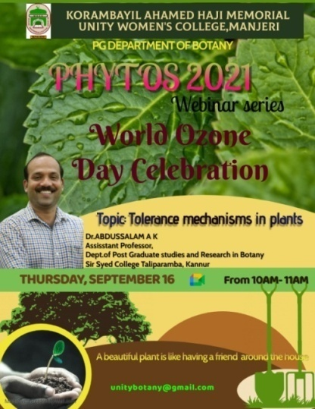
2. Talk on Gender Studies
As part of PHYTOS 2021, We, the P.G. Department of Botany conducted a webinar on the topic, “Transitioning and Gender Identity” on 23rd September 2021 at 10 am through google meet platform. The session was handled by Dr. A.P.M. Muhammad Rafeeq, Associate Professor (Retd.), Department of Zoology, Malabar Christian College, Kozhikkode. There were serious discussions on transgender community and the problems facing in our circumstances.

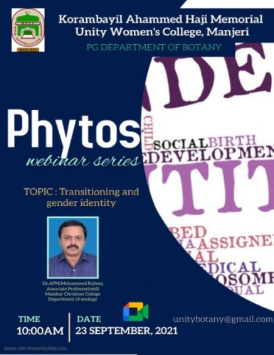

  - Workshop on Hands on Training in Horticultural techniques
Department organized one-day workshop on hands on training in Horticultural Techniques on 3rd November 2021 at 10 am in the name of “CULTURA”. Mr. Jubail. E, Farm Manager, Agricultural Research Station, Anakkayam was the resource person in the programme. Students got an opportunity to familiarize with grafting, budding, layering etc.

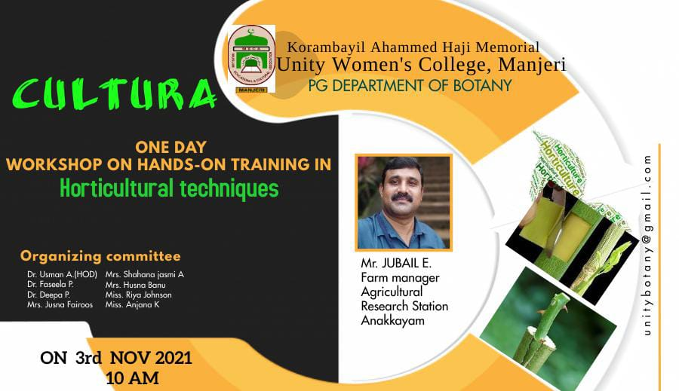

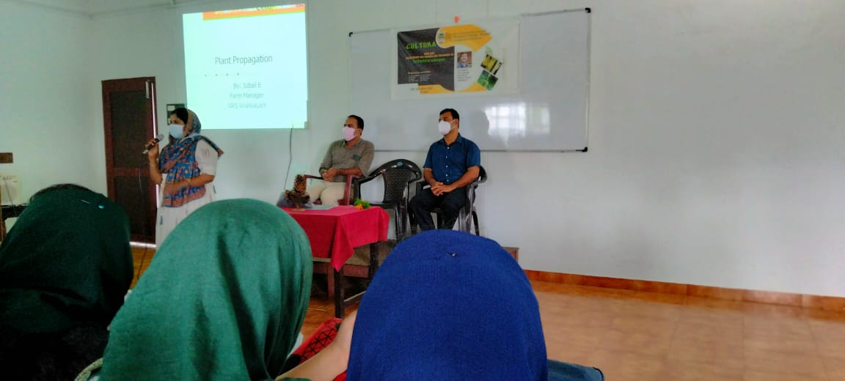

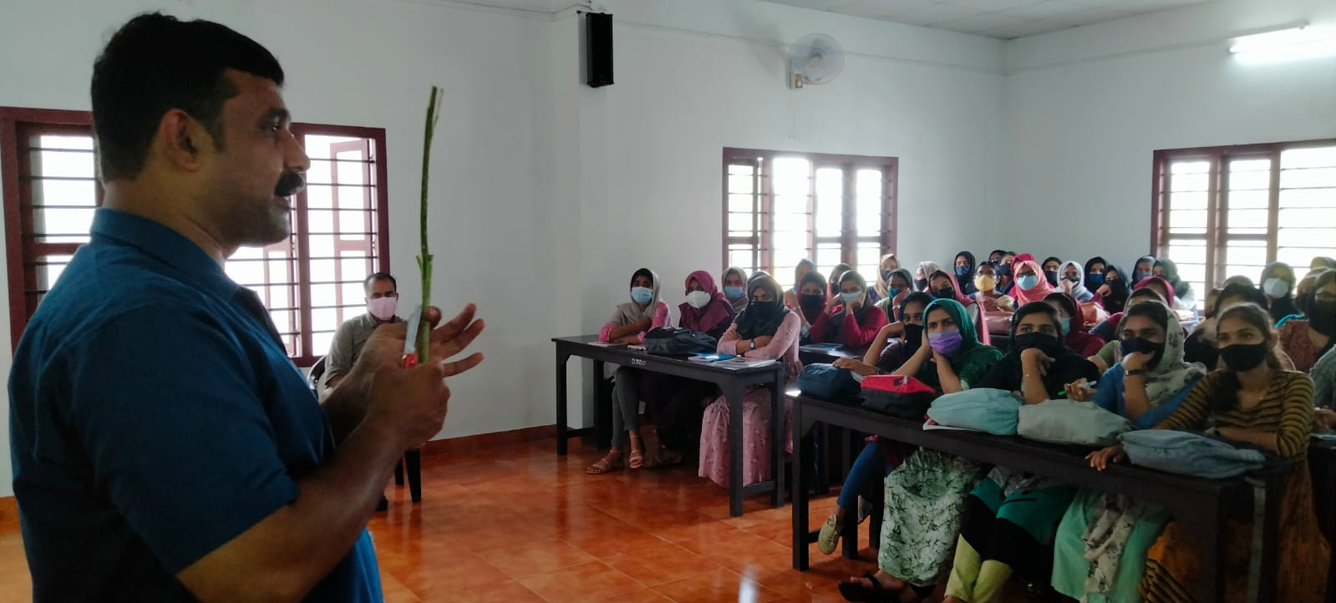

  - Capability Development Programme

We, P.G Department of Botany organized a capability development programme, “PSYCHOTRICKS” on 21st February 2022 at 10am. Mr. Suvrad M T, Chief Psychologist, ICCP, Malappuram was the resource person.
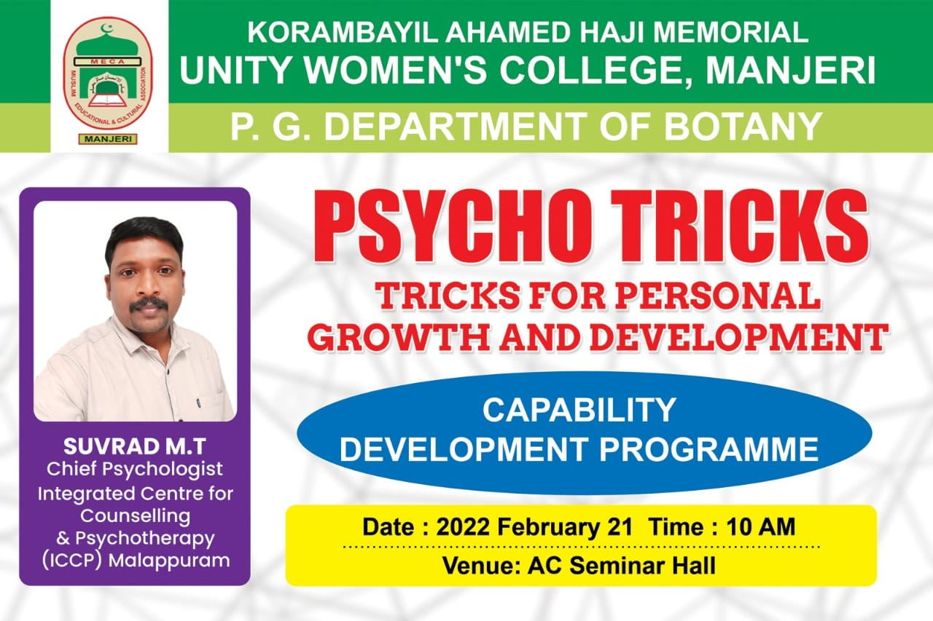

INSTITUTION/FIELD VISITS (2021-2022)

Taxonomy Collection Trip, Nelliyampathy

On 9th December 2021, Department organized a taxonomy collection trip to Nelliyampathy, Palakkad District for 3rd semester M.Sc. Botany students. 26 students with 3 faculty members were participated in the study trip and collected many plants under families mentioned in their syllabus.

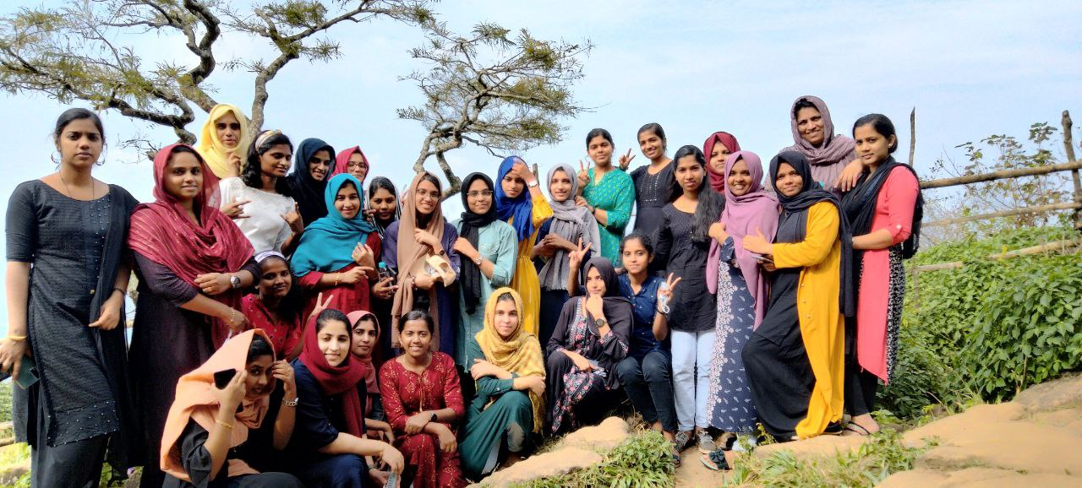
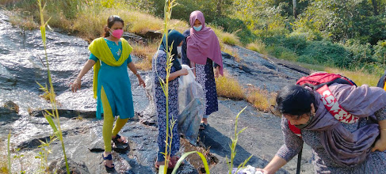

- Field Study trip to Wayanadu and Visit to ICAR- Indian Institute of Spices Research, Calicut
Department conducted a field study trip to Wayanadu and an institutional visit to ICAR- Indian Institute of Spices Research, Calicut on 13th January 2022, Thursday, for degree first semester students. 49 students with three teachers were participated in the trip.

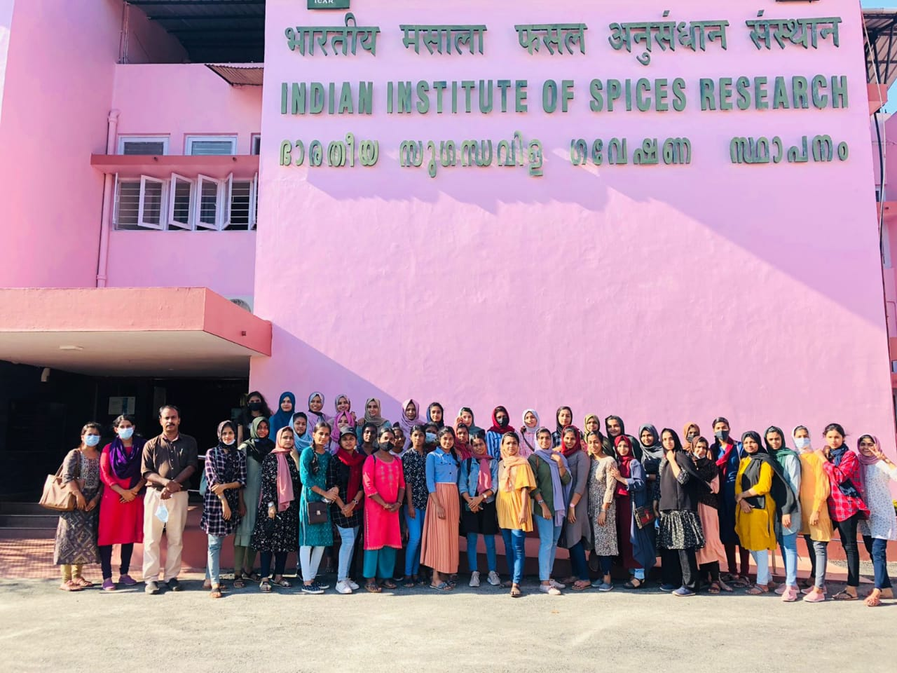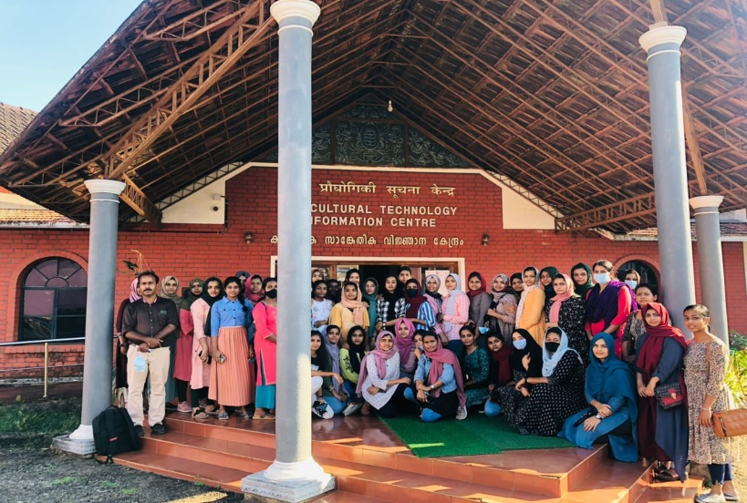
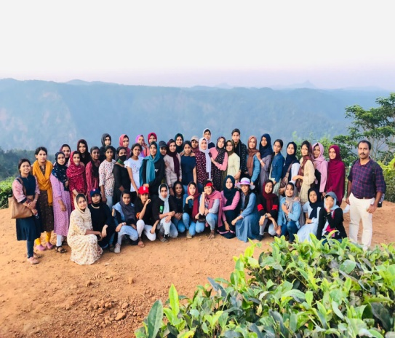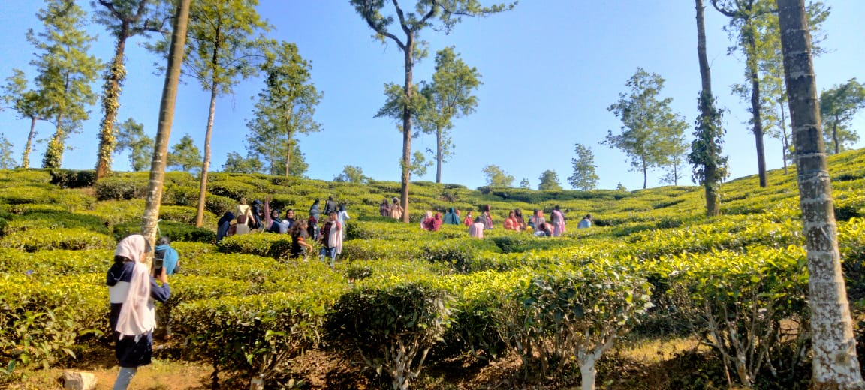

Pteridophyte /Bryophyte/Plant pathology Collection trip to Wayanad &
Visit to Gurukula Botanical Sanctury
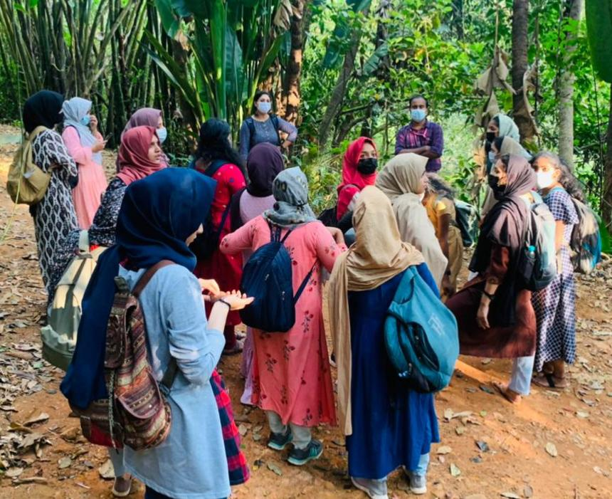
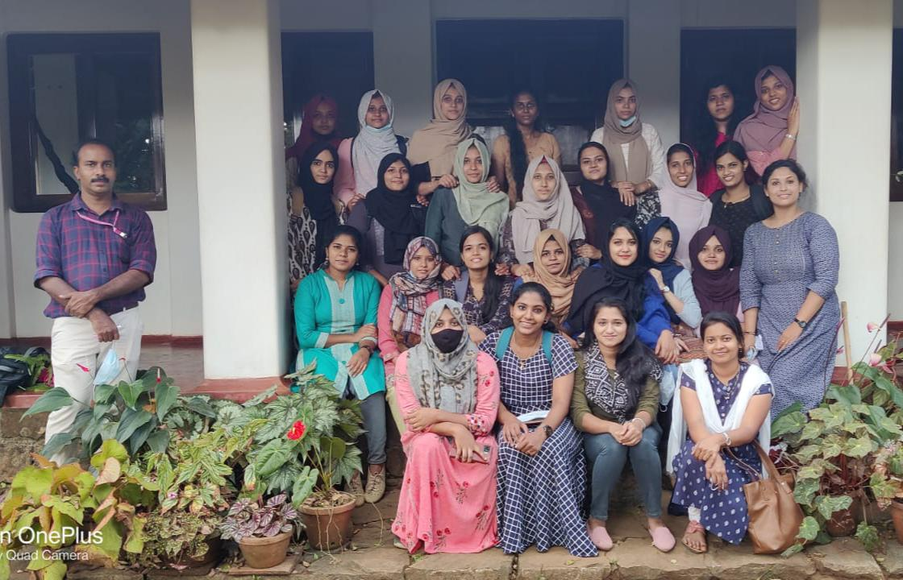
For first semester P.G students, department organized a field trip to Wayanadu on 20th January 2022, aiming collection of plant materials mentioned in the syllabus which are unavailable in our locality. 29 students and 3 faculties became a part of the trip. Besides collection, they visited Gurukula botanical sanctuary at Wayanadu, which is unique in maintaining a forest garden in the Western Ghat mountains of Kerala, India and Pookode lake.
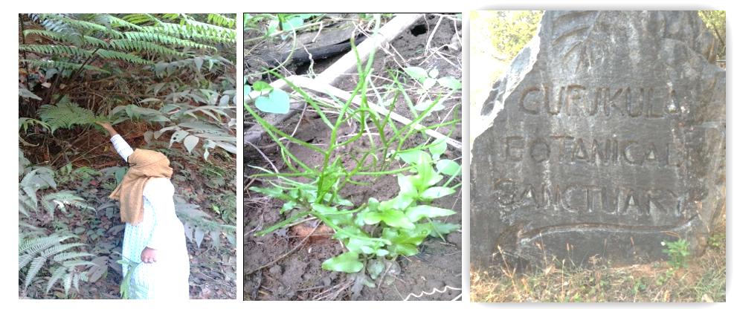

Field Study Trip to Ramakkal medu, Munnar and Ernakulam
A Field study trip for 6th semester B.Sc. Botany students was conducted to Ramakkal medu, Munnar ofIdukki District and Ernakulam on 17th, 18th, 19th and 20th of February 2022. The aim of the trip was to explore the vegetation peculiar to those areas and to visit Munnar Floriculture Centre under Kerala Forest Development Cooperation Limited. 34 students with three teachers were participated in the trip.
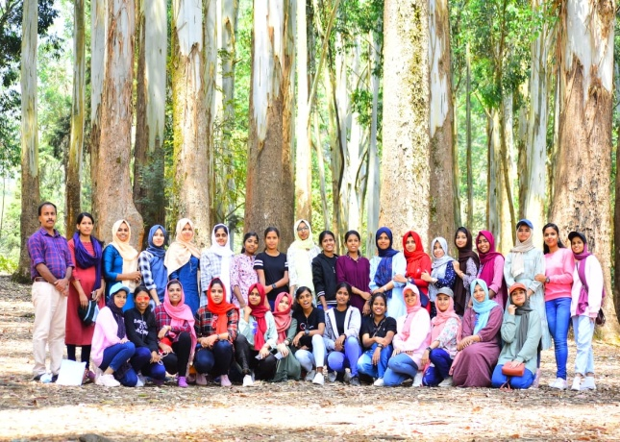

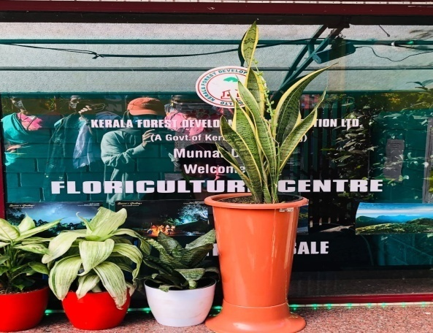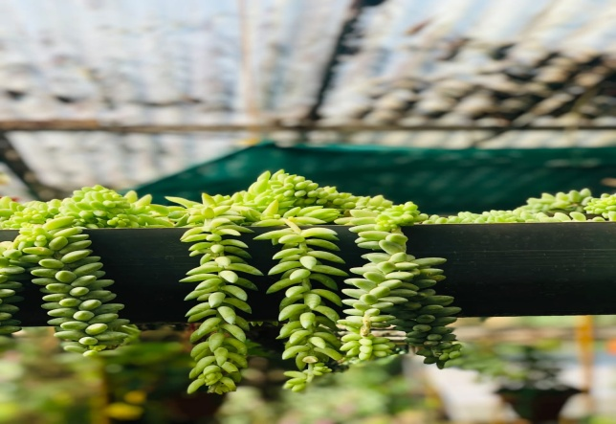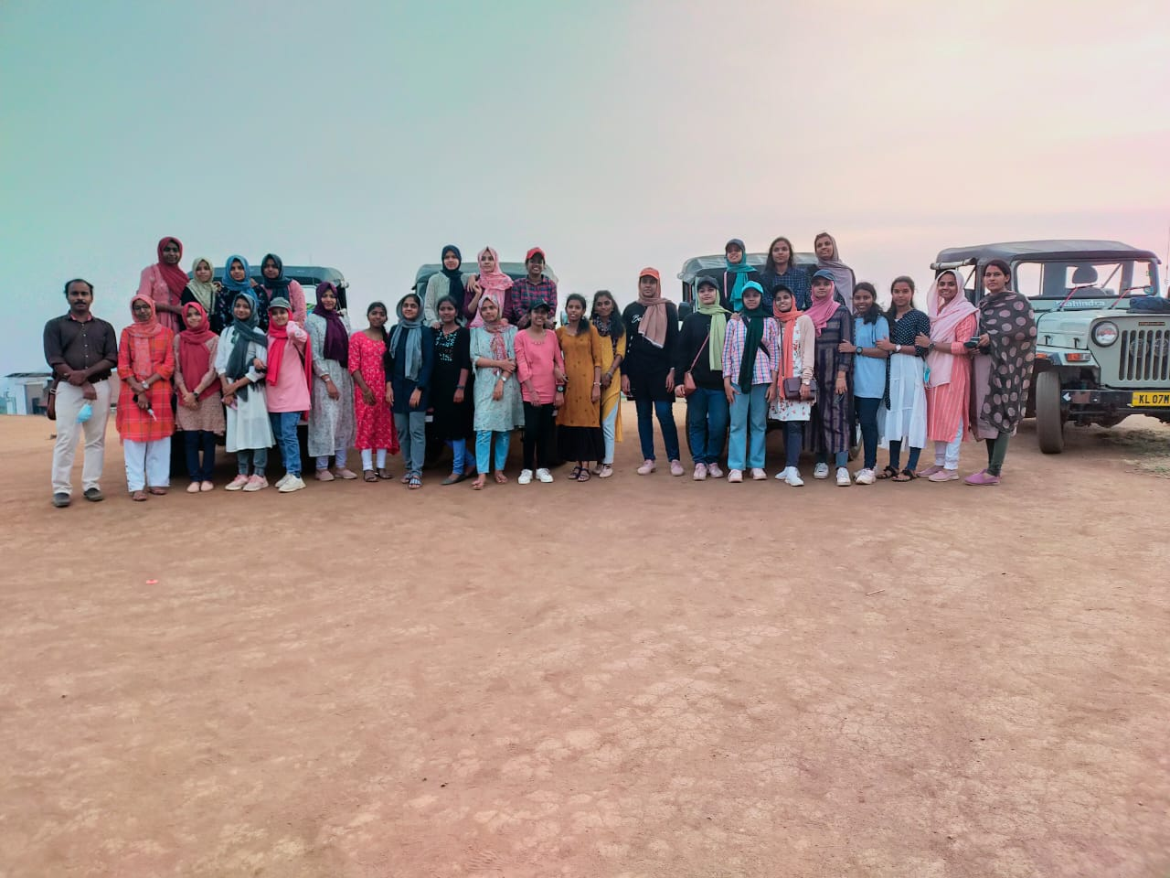
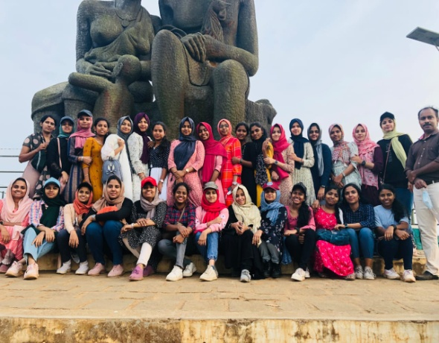
- Algal Collection and Visit to MBCHIPS, Kozhikode
As part of curriculum, our department organized a study trip to Malabar Botanical Garden and Institute for Plant Science (MBCHIPS), Kozhikode and Thikkodi Coastline for collection and study of algae. The trip was conducted on 10th March 2022. There were 28 students from first semester M.Sc. Botany and 3 faculties accompanied them. Students got good exposure rather than getting from classrooms.

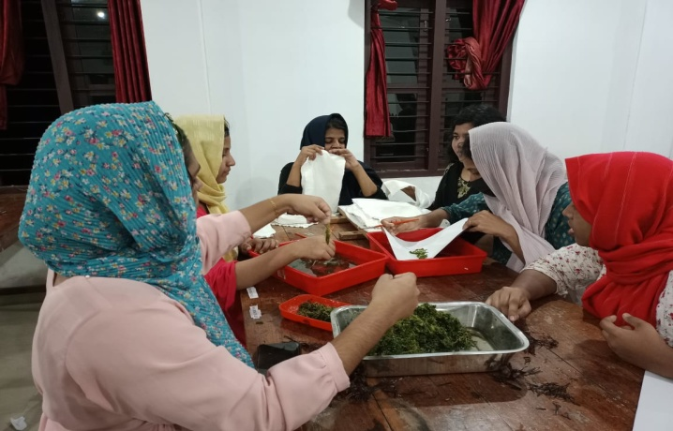
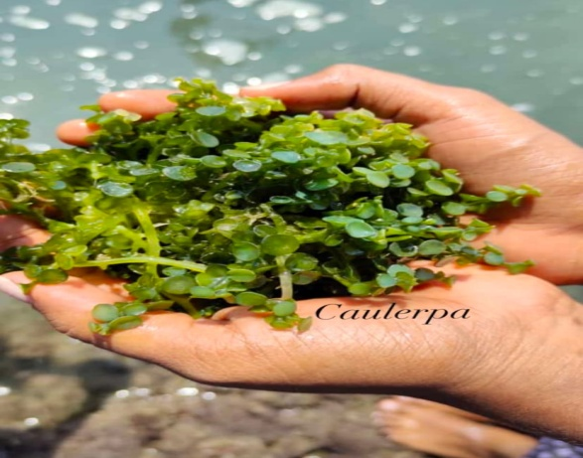

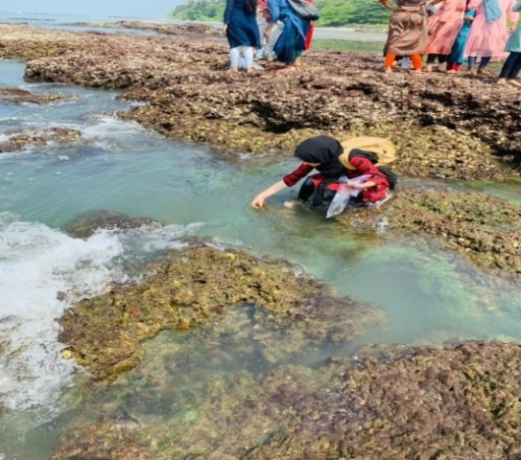

Nature camp at Attappadi Hills, Palakkad

IV semester B.Sc. Botany students of our department attended a one day nature camp at Attappadi Hills, Palakkad District, on April 1st and 2nd, 2022. Two teachers accompanied them and it gave a good exposure as well as awareness to our students towards nature protection and sustainable use of natural products.
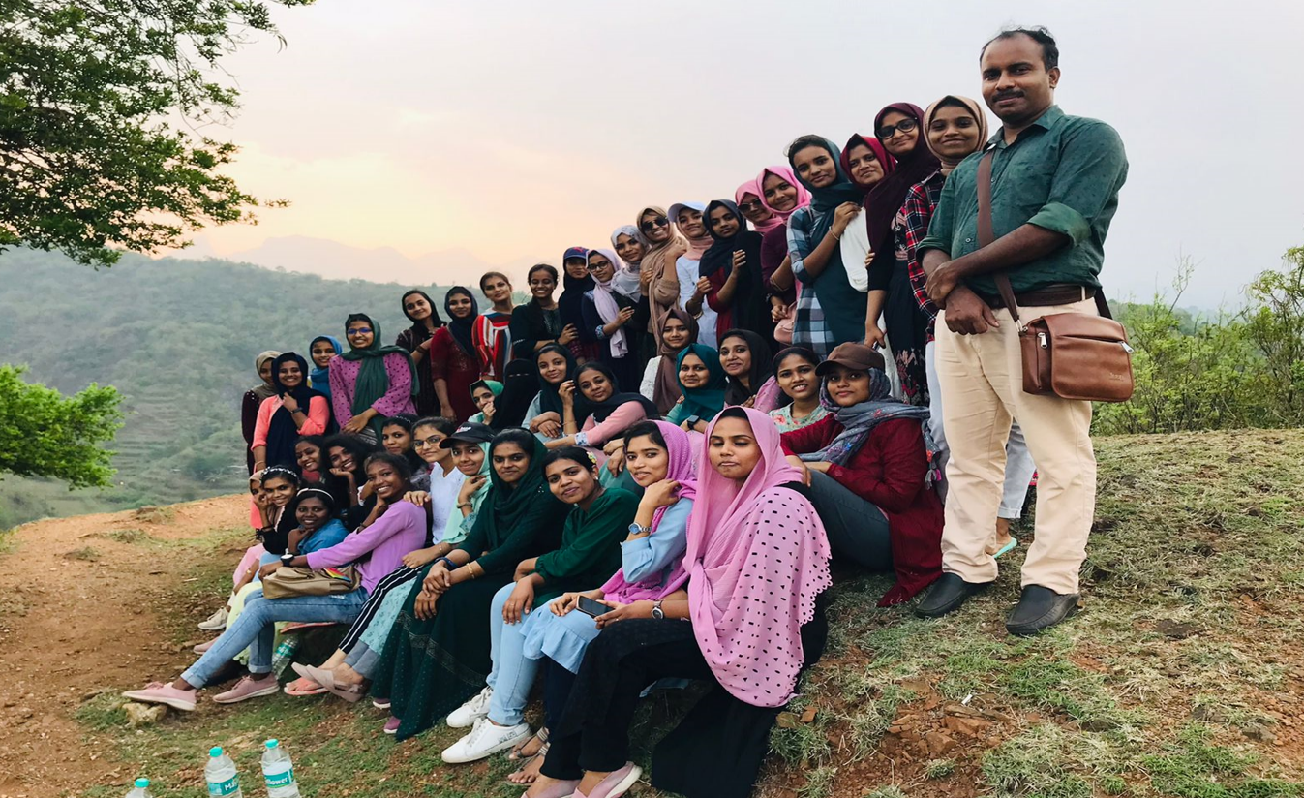

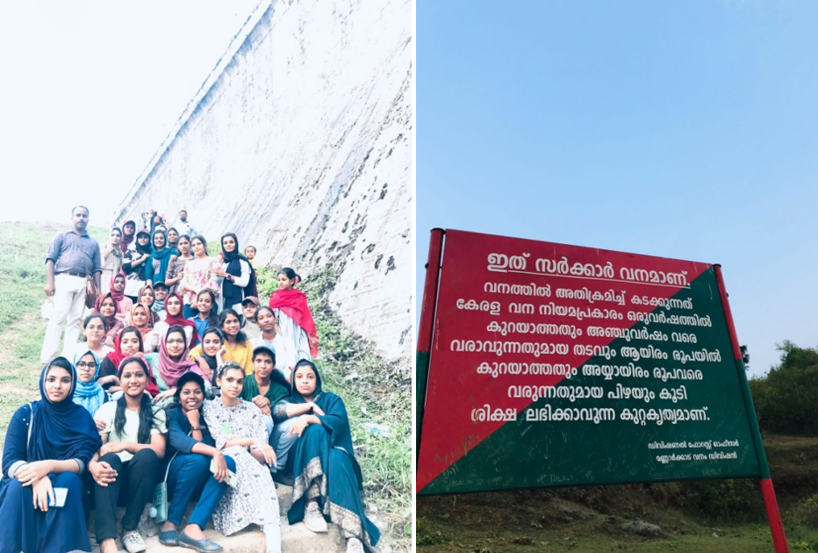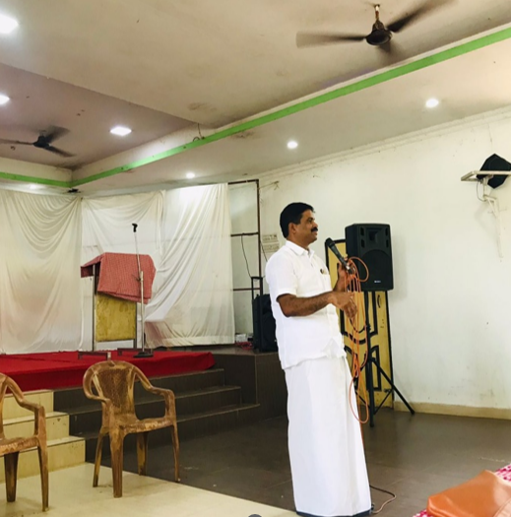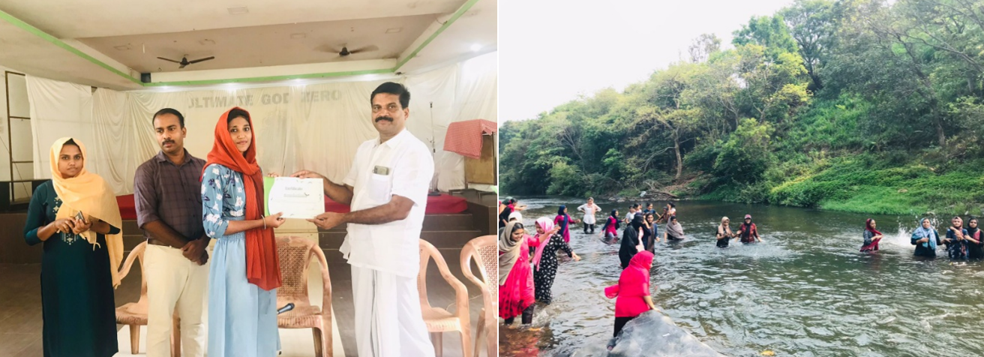

DEPARTMENT EXTENSION ACTIVITIES

1. Workshop on Mushroom Cultivation
P.G. Department of Botany conducted a one day workshop on hands on training in mushroom cultivation for plus one students of C.H.M.K.M. H.S.S Kavanur, Irivetty on 22nd march, 2022. It was very successful and students built a capability to cultivate mushrooms themselves. They were participated very enthusiastically in the programme.
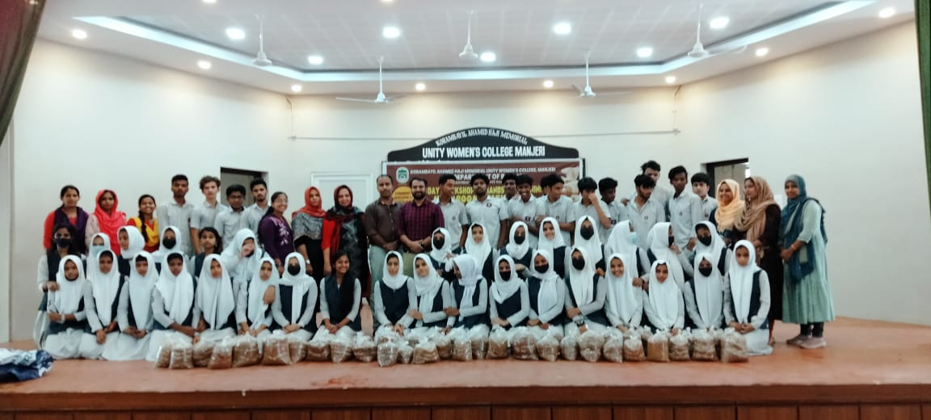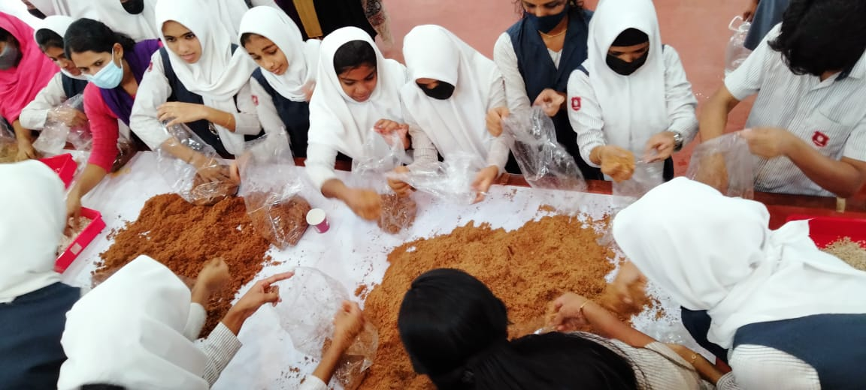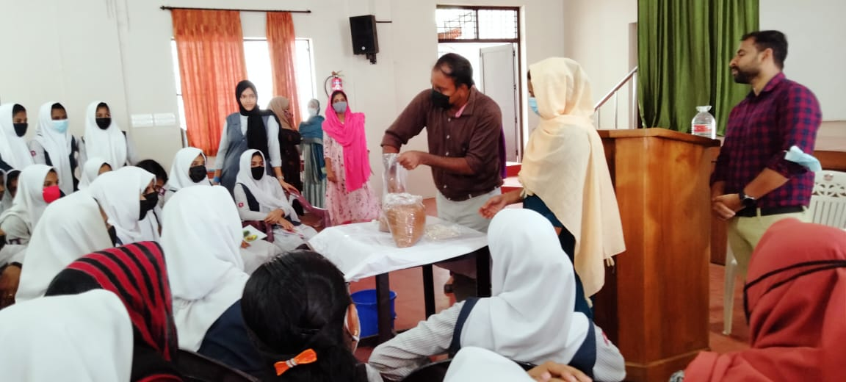
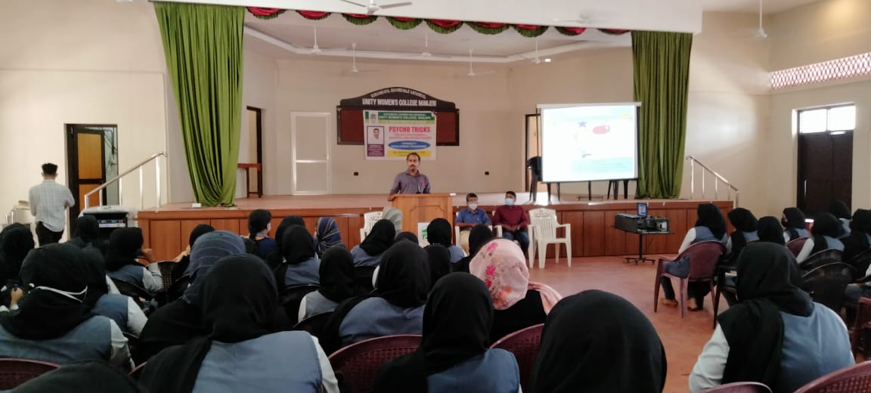
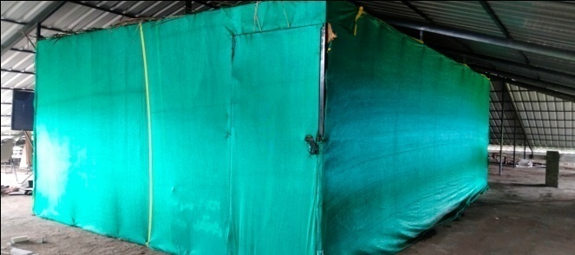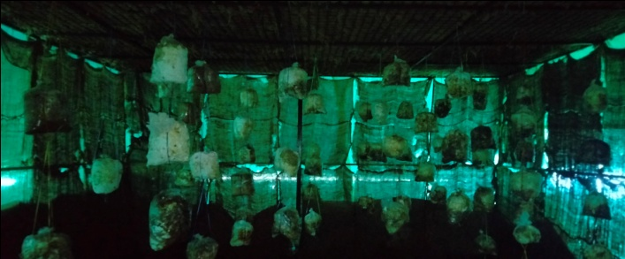
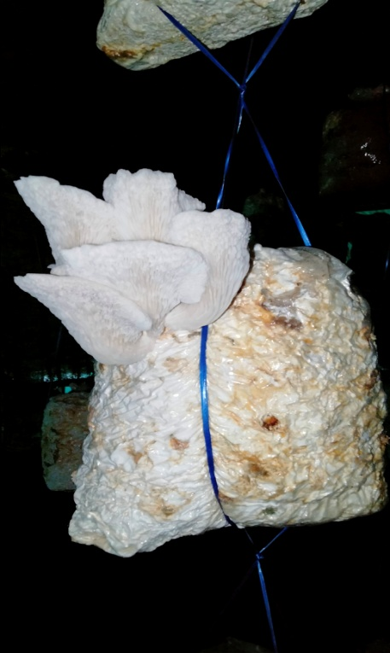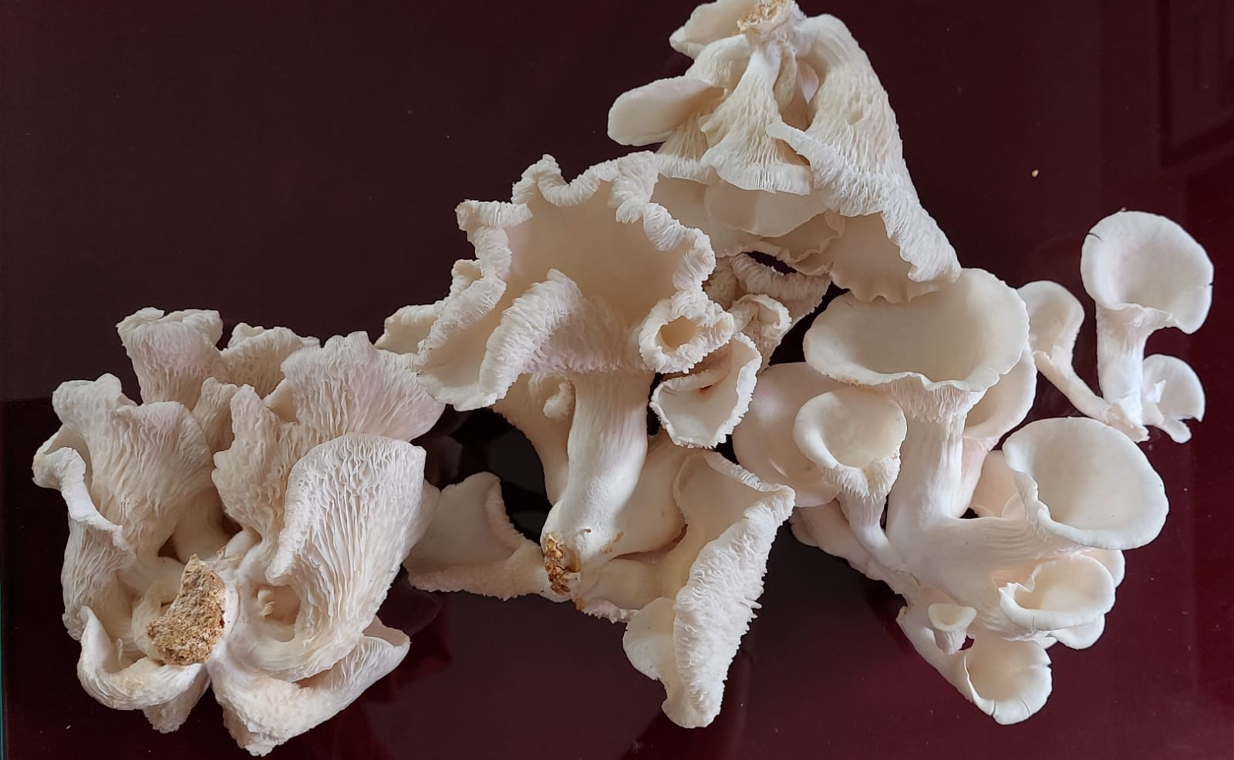

- Project based vegetable cultivation
Students of P.G. Department of Botany cultivated different types of vegetables and had set an organic vegetable garden in the college campus. The programme was initaited in association with Agriculture Development and Farmers Welfare Department, Pulpatta Krishi Bhavan and Pulpatta Grama panchayath. Seedlings of superior quality were distributed by Pulpatta Krishi Bhavan. The programme was inaugurated by Sri P.K. Ubaidulla, M.L.A on 19th November 2021 and agricultural officer at Pulpatta Krishi bhavan, Panchayath president and ward members had also participated in the inaugural function.
Agricultural Officer, Sri. Subair Babu provided proper help and advices for setting the organic vegetable garden. Baji Mulaku, Brinjal, Tomato, Kanthari Mulaku, Lady’s Finger, Cauliflower, Green Chillies etc were the major vegetables we cultivated.

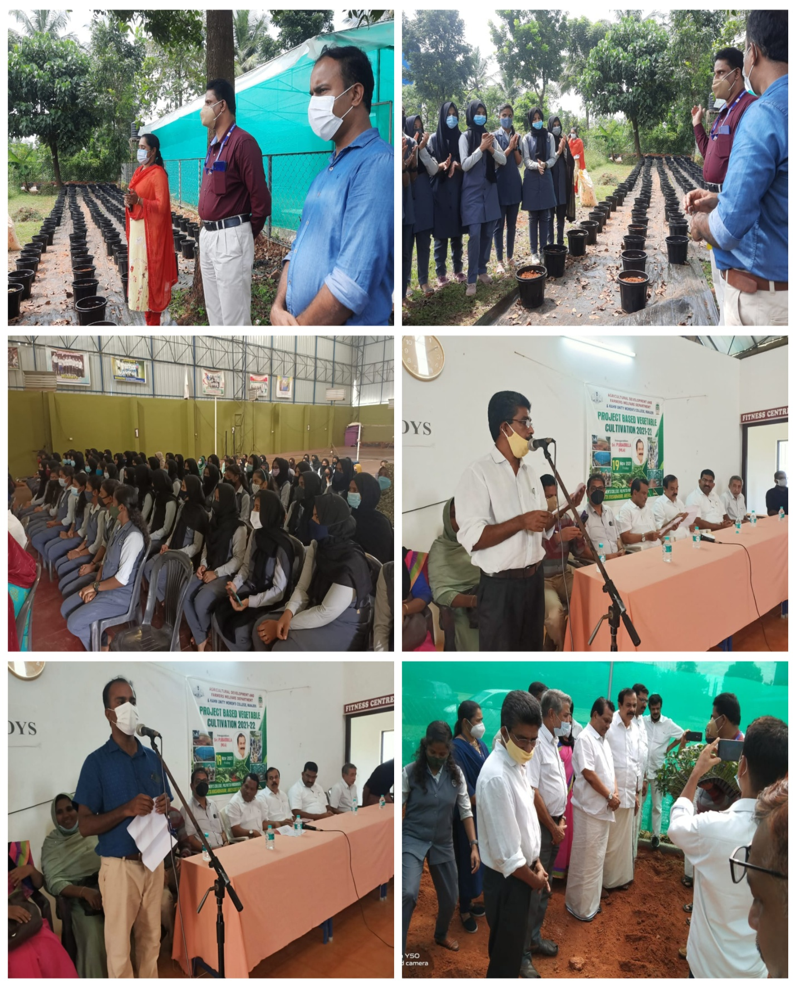
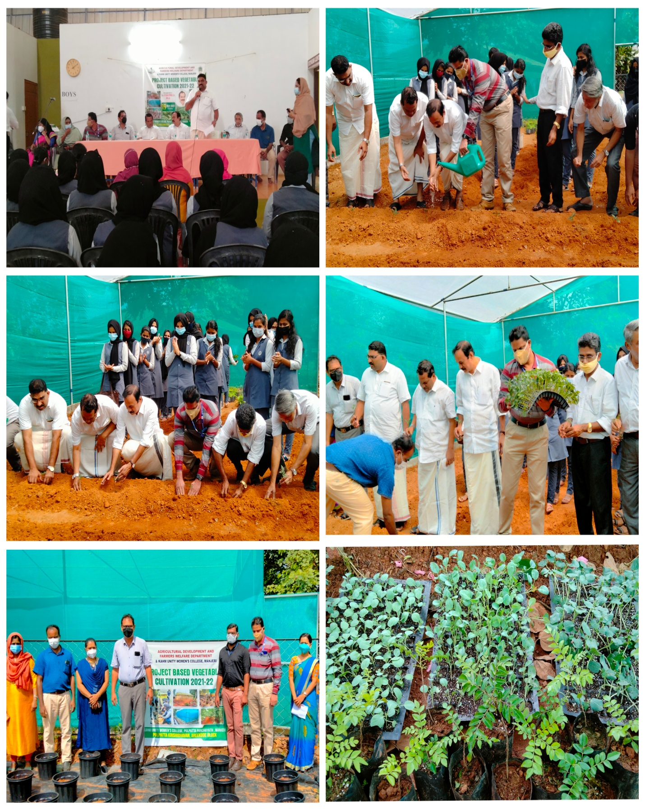

HARVESTING THE VEGETABLES

We got vegetable production more than we expected and picked up the vegetables and sold out in the campus among students and teachers by organizing one day market. The vegetables harvested during summer vacation were sold out in nearby shops also.

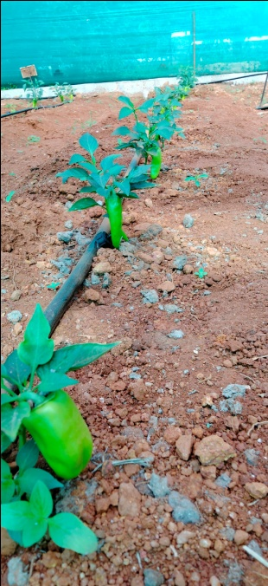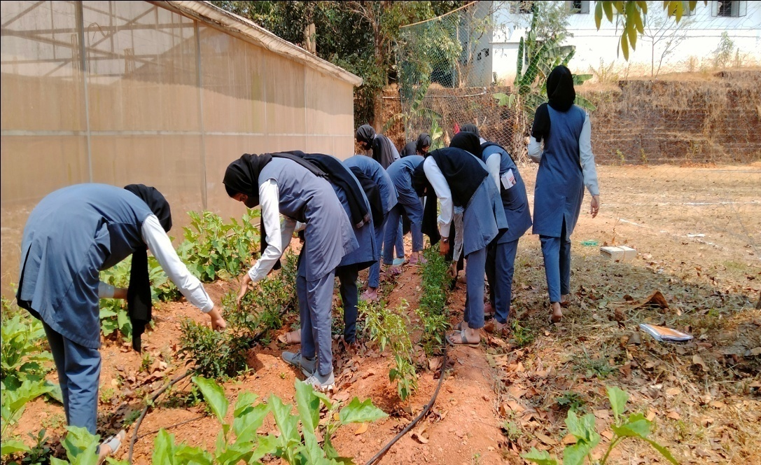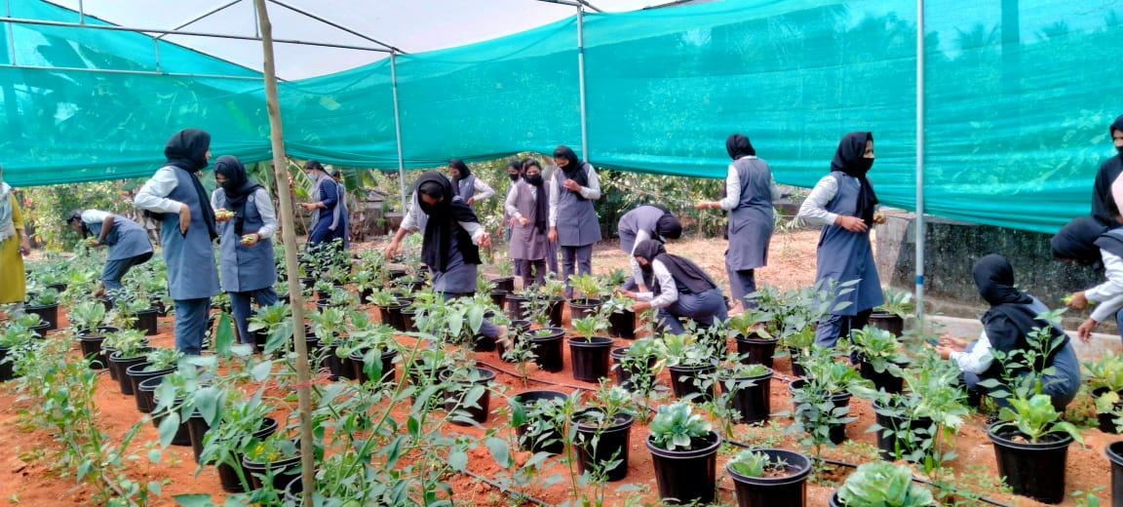

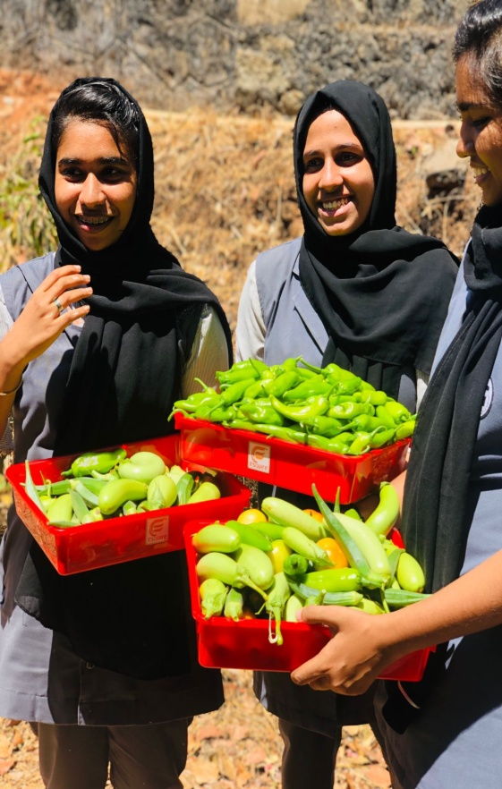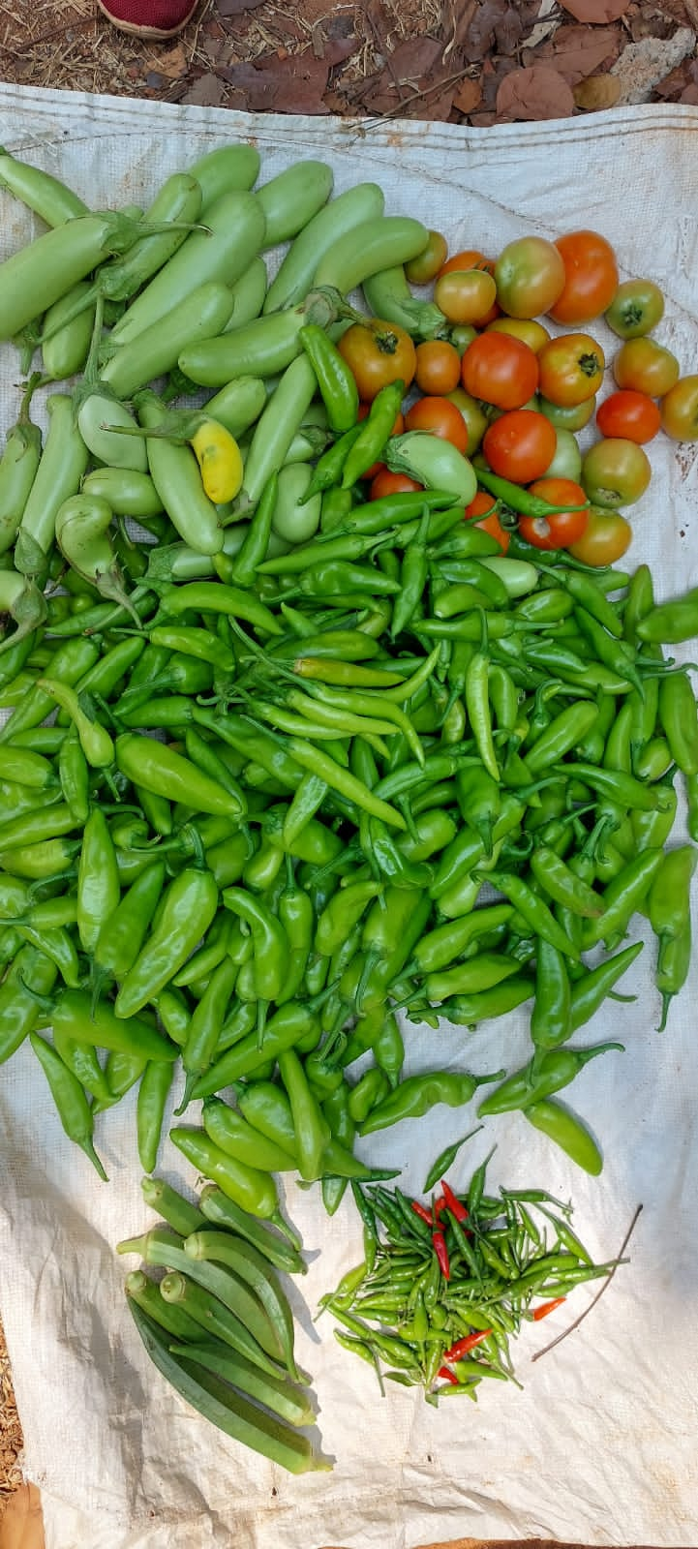
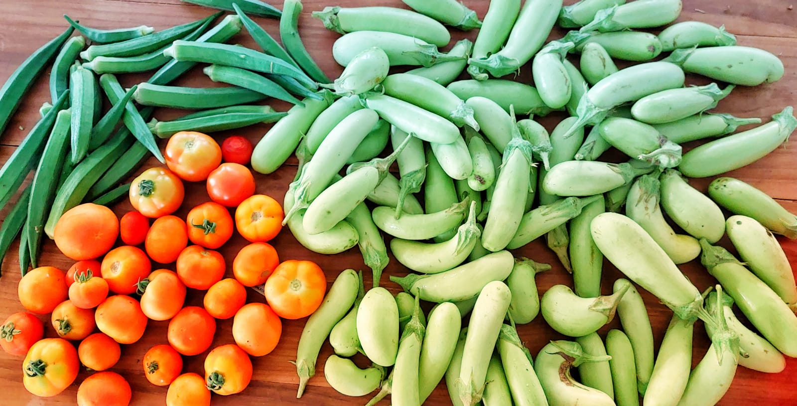

VEGETABLES SALE REPORT

